Name Matthew Ernst Date 12.5.2017

Submit your final exam through Canvas.

1.) Name the 5 Main Branches of Engineering and
Civil, Electrical, Mechanical, Chemical, Mining/Metallurgical

2.) Answer the following questions.
(This question may include other engineering branches other than the 5 “Main Branches”.)
a.) Which type of engineer builds roads? CIV
b.) Which type of engineer designs a part for a fishing reel on a CADD system? MECH
c.) Which type of engineer performs time studies? IND
d.) Which type of engineer assists in extracting minerals from the ground? META
e.) Which type of engineer assists in testing a new drug for harmful side effects? CHEM
f.) Which type of engineer maintains and operates a radio station? ELEC

3.) Create a bar chart in excel of the median salary of the 5 Main Branches of Engineering.

4.) For the following listed Job Functions, Classify each as most appropriate for an Engineer, technician, or skilled worker.
- Repairs a hydraulic control valve: ___SW____
- Designs a computer network: ENG
- Supervises an assembly operation: TECH
- Troubleshoots a faulty hydraulic circuit: TECH
- Repairs a TV Set: SW
- Breadboards a newly designed circuit: ENG
- Designs a data collection system for a warehouse: ENG
- Consults on materials for a new product: SW
- Designs a new production line: ENG
- Supervises the installation of an elevator: TECH

5.) What does the increase in automation have to do with the need for technicians in industry?
Technicians will be needed to help troubleshoot problems and supervise assembly lines in automation. They will be needed when new automation systems are being put into practice for them to design.

6.) When I was in the Army I owned a 305 cc Honda Super Hawk CB77. Some of the specifications for the motor were: 54 mm stoke, four-cycle, and two-cylinders. The original 305 engines were paired with a four-speed constant mesh transmission. Find the total engine displacement in cubic inches and liters. Also find the bore in mm.

Bore = 60 mm
Engine Displacement = 18.6122 in³
Engine Displacement = 3.05 L

7.) A concrete pad is going to be constructed for a helicopter landing pad. The pad is 40’x70’. The concrete pad will 12” thick on top of 9” of crushed stone.
- How many cubic yards of stone must be purchased? 77.8
- How many cubic yards of concrete must be purchased? 104
- The average concrete truck holds 11 cubic yards of concrete. How many concrete trucks should the technician expect on the day the concrete is placed? 9.5

8.) Name the seven “Fundamental Units”.

a.) Length
b.) Mass
c.) Time
d.) Electric Current
e.) Temperature
f.) Luminous Intensity
g.) Amount of Substance

9.) Convert 20 C° to K, F° and R° (show all calculations)

20 C° = 293K 20C + 273K = 293K
20 C° = 68 F° ((9/5)*20) + 32 = 68F
20 C° = 527.4 R° 293K * 1.8R = 527.4R

10.) Create a chart in Excel with the C° as the X Axis and K, F° and R° on the Y axis. The X-axis should go from 0 C° to 100 C°

11.) Your boss would like you to determine the Mean, Maximum, Minimum and Standard Deviation of 25 resistors. The resistor values are:

Mean = 1048
Maximum =1190
Minimum = 970
Standard Deviation = 70.45

12.) Using the test data from Problem 11 answer following questions assuming that the purchased resistor value is 1000 ohms: If the part tolerance was 20% do all samples meet the tolerance requirement? Yes

13.) Open Excel and create a plot of the 25 resistor samples for problem 11. The plot should include:
A title and labels for the X and Y axes. Once you have created the plot print it out and attach it to your final exam.

14.) Using Excel, create the plot for I=E/R when E=12.0 Volts and R=100,220,330,470, 1K, 2.2K, 3.3K, 4.7K, 10K (Calculate each “I or current” value & plot)

15.) Using Excel, create the plot for 2^{X} as X varies from 1 to 8. (Calculate each value & plot)

16.) Using the Pythagorean Theorem, solve for the missing sides of the following right triangles.
- Side a = 6, Side b = 8, Side c = 10
- Side a = .04, Side b = .09, Side c = .098
- Side b = 19.2, Side c = 28.7, Side a = 21.33
- Side a = 1/4, Side c = 1, Side b = 0.968
- Side a = 12 mi, Side c = 13 mi, Side b = 5

17.) Given the following information for a right triangle in standard position (See below), solve for the selected side or angle.
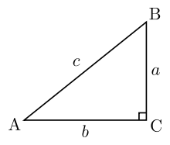
- a = 3, c = 5, A = 36.87
- a = .79, c = 1.88, B = 65.15
- A = 37 degrees, b = 18, c = 22.54
- B = 12 degrees, c = 85.3, b = 17.73
- A = 53.9 degrees B =36.1 , b = .003, a = .004

18.) The guy wires for an antenna tower are attached 36 m above the ground. If the other end of the guy wires must be attached to the ground plane, 42 m from the base of the tower, what is the length of each wire? What is the angle of the wires at the ground?
Length of the wire: 55.32m
Angle of wire to ground: 40.6 degrees

19.) The following data was recorded during an experiment. Graph the data in Excel:

Revolutions per Minute (RPM) of Pump Gallons per Minute (GPM) of Pump Output
0 0
100 .5
220 1.4
310 2.6
400 4.2
498 6.0

20.) From resistance (R2) of a wire varies according to the temperature (t) as the Graph in problem 19, fine the pump output at 250 RPM: 3.3 GPM

21.) The

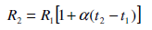

The factor (α) is found at http://www.allaboutcircuits.com/vol_1/chpt_12/6.html. Compare the resistance of aluminum and copper wires at 100°C (t2) with R1 equal to 20 ohms at 10°C (t1).
Aluminum: 27.75644 Copper: 27.2738

22.) A right triangle has a single side and angle known: A=30° and c=47, what are the lengths of “a” “b” and angle B? Also, show how you would check your answer to insure it is right. (Show all work)
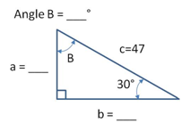

Angle B = 60 degrees, a = 23.5, b = 40.7

23.) The I-beam shown in Figure 6.25 is modified so that there are 2 equally space 1.5 inch holes and 6, ¾ inch holes in the top and bottom flanges. It represents a 24 inches section. The weight density of steel is 7850 kg/m³ or 0.284 lb/in³.

- Calculate the total weight of an 8 foot piece in pounds. 519.95
- Calculate the total weight of an 8 foot piece in kilograms. 235.868
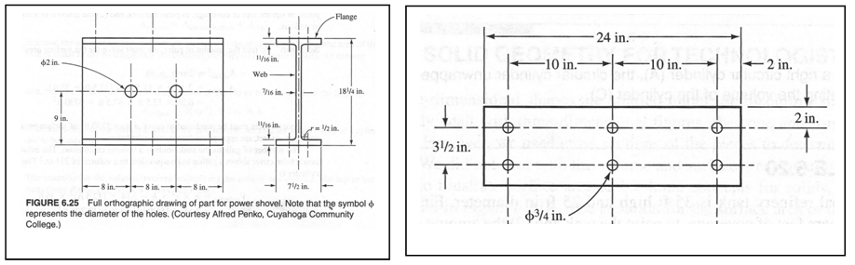

24.) Two force vectors are pulling on an object determine the magnitude and angle of the resultant force vector. (show all work)

F1 = 250 lbs @ 60°
F2 = 150 lbs @ 45°
FR = 400 lbs @ 75°

25.) In 100 words or more describe your best options for a promising career over the next 20 years?
I would like to hopefully become a machinist as the ultimate goal for my career choice for the rest of my life. I love math, science, and manipulating numbers. As for a people standpoint, I love to work with others, troubleshoot and design, and communicate effectively with other people to achieve a common goal. I hope to be someone that can help engineers implement new systems that may hopefully move the world forward in the coming years.

